Patrick Woodrum Artifact for Sprint 7

Create guided window “progression” for sandbox/tutorial

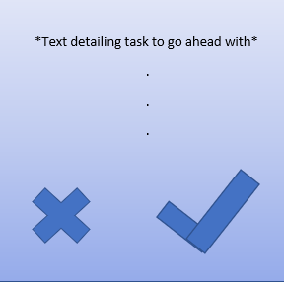

Possible picture showcasing completed task

Task at hand up top

Close button on bottom left

“Done” button on bottom right

**Task Constraints:**

-During each individual task, the “done” button will be greyed out or toggled off

-Once the user completes the task by, say, placing each cube in its correct zone, the “done” button becomes untoggled and able to progress

**Needs:**

-Physical window design

-Scripting for toggling buttons on and off

-Scripting supporting each task’s progression

-Progression counter

-“Reset” button in case mistakes are made or user is lost